SpendWise
A Simple Backend Learning Project
Design Phase II · Data Flow Diagram & User Stories

Date | 13 February 2026
Project Name | SpendWise
Document Type | Design Phase II — Data Flow Diagram & User Stories
Team ID | SWTID-2026-1005

Overview
This document covers two core design deliverables for SpendWise. The Data Flow Diagram (DFD) shows how data moves through the backend — from a user's first request, through authentication, to CRUD operations on the database. The User Stories define what the system must allow each user to do, expressed in plain language with testable acceptance criteria and sprint assignments.

1 | Data Flow Diagram  How data moves through the SpendWise backend from request to response.

Flow Node Reference
Node | Layer | What It Does
Start | Entry | User makes their first request to the SpendWise API.
Home | Routing | Routes the incoming request to the backend Express server.
Backend API | API Layer | Node.js + Express receives and processes all requests.
Register User | Auth | Creates a new user account and stores credentials in MongoDB.
Login User | Auth | Validates credentials and issues a signed JWT token.
Get JWT Token | Token | JWT is returned to the client after successful login.
Protected APIs | Security | Middleware verifies the JWT before allowing any CRUD access.
CRUD Operations | Logic | Core layer — Create, Read, Update, Delete in MongoDB.
Create / Read / Update / Delete | Data | Individual database operations on user-owned records.

Step-by-Step Data Flow
# | Action | What Happens
1 | Request enters the system | Routed from Start through Home to the Express backend.
2 | Route identified | Express matches the URL and method to the correct handler.
3 | Register or Login | New users register; existing users log in with email and password.
4 | JWT Token issued | Successful login returns a signed JWT to the client.
5 | Token sent with next request | Client adds JWT as a Bearer token in the Authorization header.
6 | Middleware validates token | Protected routes reject missing or invalid tokens immediately.
7 | CRUD operation executes | Authorised request runs Create, Read, Update, or Delete.
8 | Response returned | Data or success/error message is sent back to the client.

Key Design Rule
JWT is the only gate to CRUD — no token, no access.
Every CRUD query filters records by the authenticated user's ID, ensuring data privacy.
Each node has a single responsibility: route, authenticate, or operate on data.

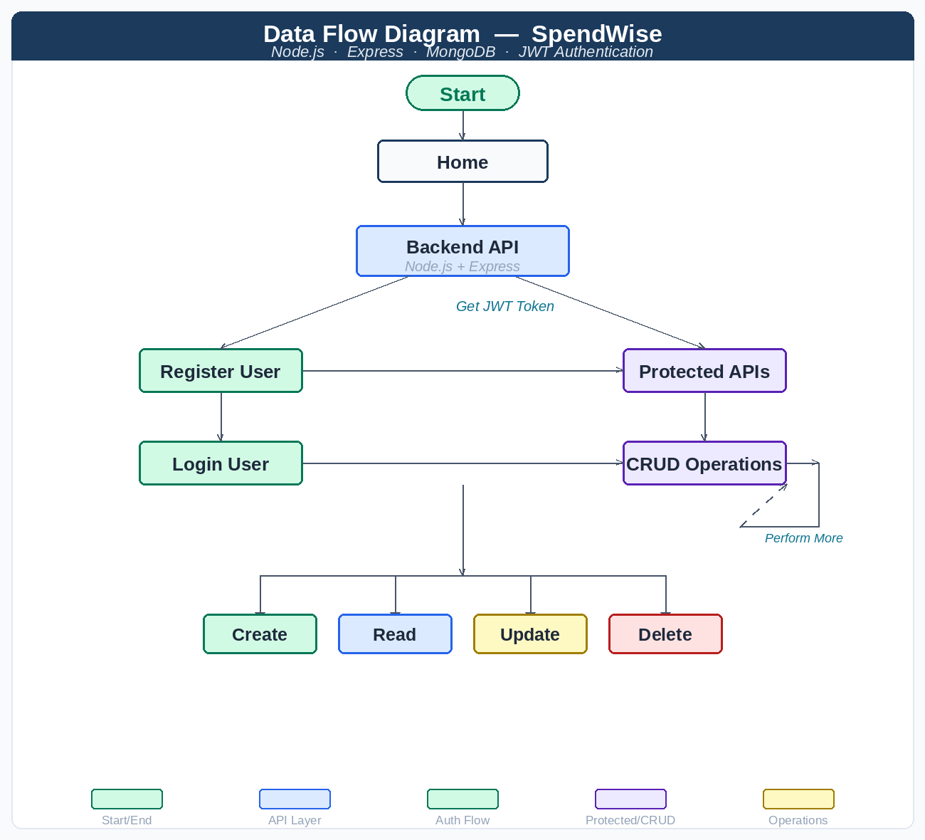

2 | User Stories  What the system must do, written from the user's perspective with acceptance criteria.

User story number | User Type | User Story / Task | Acceptance Criteria | Priority | Sprint
Sprint 1 — Authentication
USN-1 | API User | As a user, I can register using name, email, and password | User creates an account and receives a success response | High | Sprint 1
USN-2 | API User | As a user, I can login using email and password | User receives a valid JWT token after successful login | High | Sprint 1
Sprint 2 — CRUD & Security
USN-3 | API User | As a user, I can access protected APIs using a JWT token | Requests without token are rejected; valid token allows access | High | Sprint 2
USN-4 | API User | As a user, I can create a new record / transaction | Record is saved in the database and returned in the response | High | Sprint 2
USN-5 | API User | As a user, I can view all my records / transactions | User receives only their own records from the system | High | Sprint 2
Sprint 3 — Full CRUD & Data Privacy
USN-6 | API User | As a user, I can update my record / transaction | Selected record is updated and new data is returned in the response | Medium | Sprint 3
USN-7 | API User | As a user, I can delete my record / transaction | Selected record is removed and a success message is returned | Medium | Sprint 3
USN-8 | API User | As a user, I cannot access other users' data | System blocks access to any record that does not belong to the requesting user | High | Sprint 3

Acceptance Criteria Note
Every criterion is binary — it either passes or fails in a Postman test.
High-priority stories (USN-1 to USN-5, USN-8) form the minimum viable product.
USN-8 is High priority because user data isolation is a security requirement, not a feature.

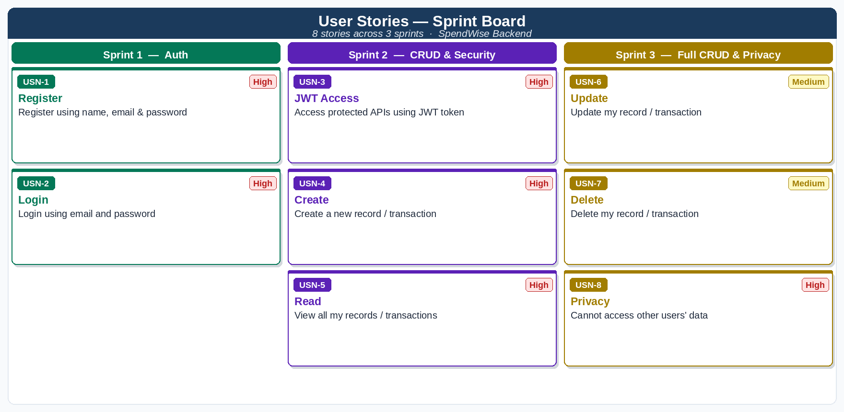

3 | Sprint Planning Summary  Distribution of user stories across the three development sprints.

Sprint | Stories | Focus Area | Definition of Done
Sprint 1 | USN-1, USN-2 | Authentication — Register & Login | POST /register returns 201; POST /login returns JWT token
Sprint 2 | USN-3, USN-4, USN-5 | JWT Protection + Create + Read | Protected routes reject invalid tokens; POST and GET /records work correctly
Sprint 3 | USN-6, USN-7, USN-8 | Update + Delete + Data Privacy | PUT and DELETE /records/:id work; cross-user access is blocked

Priority | Count | Story IDs
High — must be delivered in Sprint 1 or 2 | 6 | USN-1 to 5, USN-8
Medium — targeted for Sprint 3 | 2 | USN-6, USN-7

Project Complete When
Sprint 1: /register returns 201 and /login returns a valid JWT.
Sprint 2: All CRUD endpoints return correct, user-scoped data for authenticated requests.
Sprint 3: PUT and DELETE work; USN-8 blocks any cross-user data access.
All 8 acceptance criteria pass in the included Postman collection.

